FACULTY EVALUATION
Programme Name: SBVP ALUMNI MASTERCLASS - SCALE Module I Online Zambia (20th April 2026 - 24th April 2026)
Session: Reflection of SEP Learning
Faculty Name: Benard Chege
No. of Respondents: 13
No. of Participants: 13
Evaluation Parameter | (%) Individual Score | (%) Programme Average
Punctuality | 95 | 19
Clarity of presentation of concepts, course material, content and use of practical examples. | 92 | 18
Degree of preparation for the lessons | 83 | 17
Course design and organisation | 92 | 18
Content and methodology | 92 | 18
Quality of discussions | 83 | 17
The information presented was relevant to my work | 89 | 18
Average scores | 89 | 18

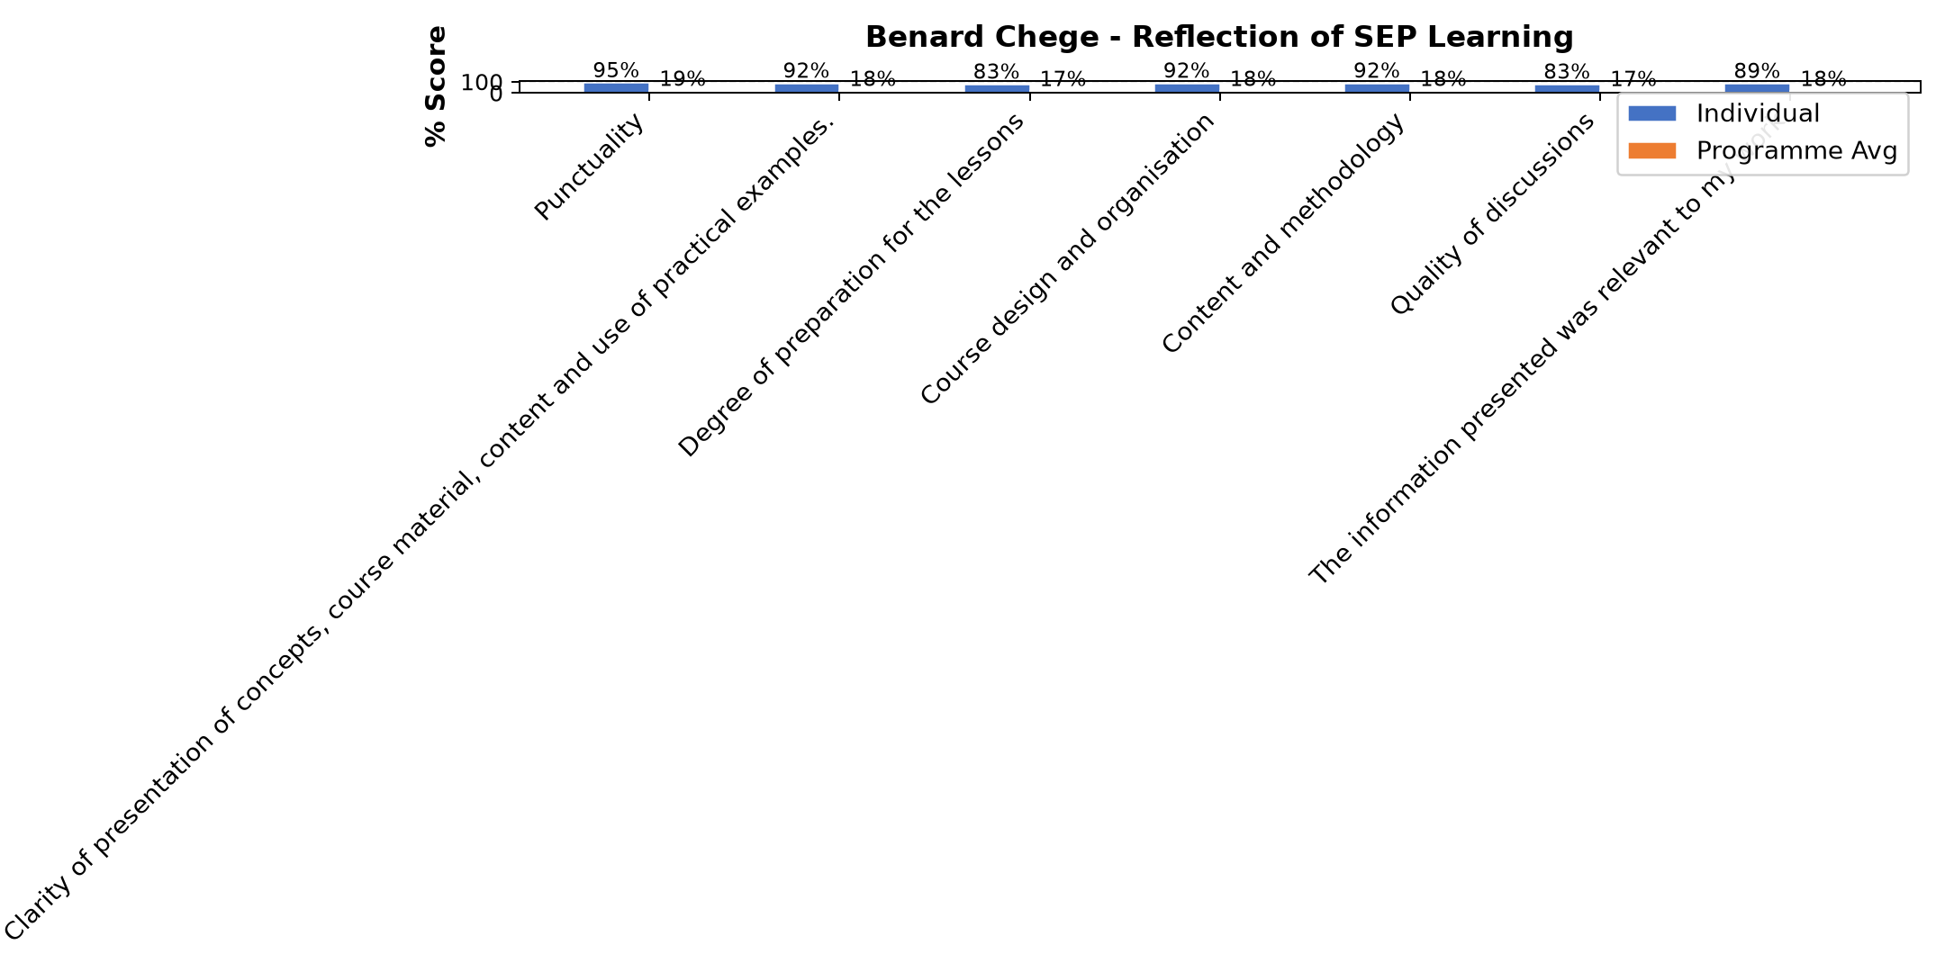

Comments & Feedback
- • Financial resources is the major barrier. The second burrier is to break the mind set of the beneficiaries
- • I am not on the ground of our project at the moment but can encourage from a distance
- • Finance
- • None for now
- • There are no barriers. The class today was very clear. I was able to follow the course with gratitude.
- • Donor dependency and fear of losing funding and lack of market data and pricing skill
- • Donor dependence
- • Depending on donors
- • Internet network
- • Working with my sisters whom we not share the same understanding
- • No barrier will prevent me
- • The barrier I am facing is I am not the one that make decision in the school where I am working.
- • Slowness of contractors to construct the hostel
SUBMITTED THROUGH:
SBS Evaluation Automation System

